

# Software Design Applications

# Gimmick Games Deployment Document

COM326

## Professor: Alparslan Horasan

Prepared by:

Abdulmohaimin Bashir (B2205.010021)

Muhammad Bilal (B2105.010028)

Mohammed Islam Haji (B2205.010022)

Nusaibah Mekkaoui (B2205.010015)

# Access to Gimmick Games Website Through a Link:

We have used *Render* to deploy and host our website. As a result, and with a stable internet connection, Gimmick Games is accessible to the end user through the following link:

# <https://gimmickgames-1.onrender.com>

# Access to Gimmick Games for the Local Machine:

To access Gimmick games through your local machine, the user is required to implement the following steps:

* Check if Node.js is installed on your machine:
  + 1. Go to your command prompt and type in “node -v“
    2. If Node.js is installed then you should get a version number such as the following: “v20.13.1“; a lower number indicates an earlier version is installed.

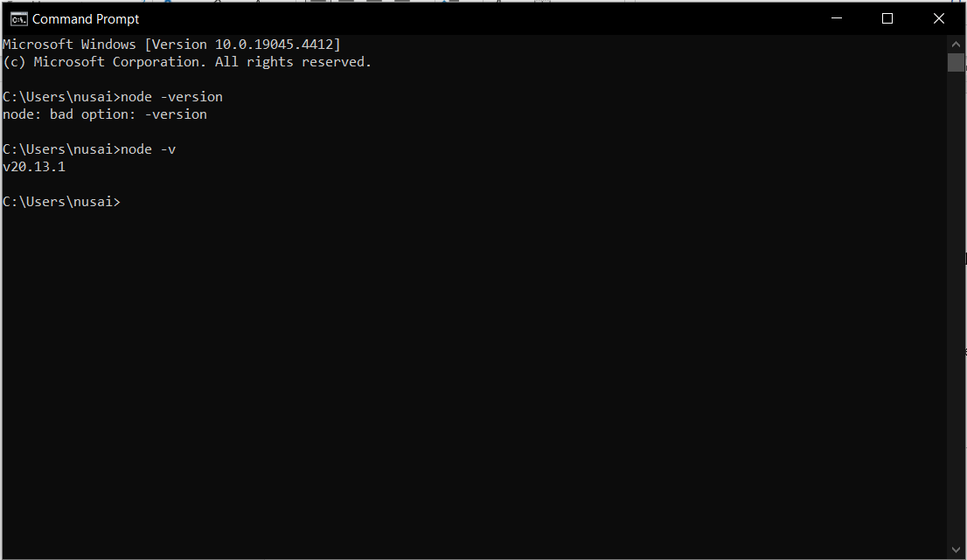

* + 1. If Node.js is not installed, head over to <https://nodejs.org/en/download/prebuilt-installer> , select your OS and processor then hit download (Preferably the TLS version). Once the download is over, open the installer and follow the wizard’s instructions to install Node.js.
    2. Go back to the command prompt and follow step 1 and 2 to check if Node.js has installed successfully by checking the version.
* Download the Gimmick Games zipped folder and extract it.
* Open the folder in any IDE or text editor.
* Open a new cmd terminal and enter “npm run serve”. This should start the server and connect to the database MongoDB. The following message should show up:

> gimmick-games@1.0.0 serve

> node app.js

Server started on PORT : 3000

Connected to MongoDB

* 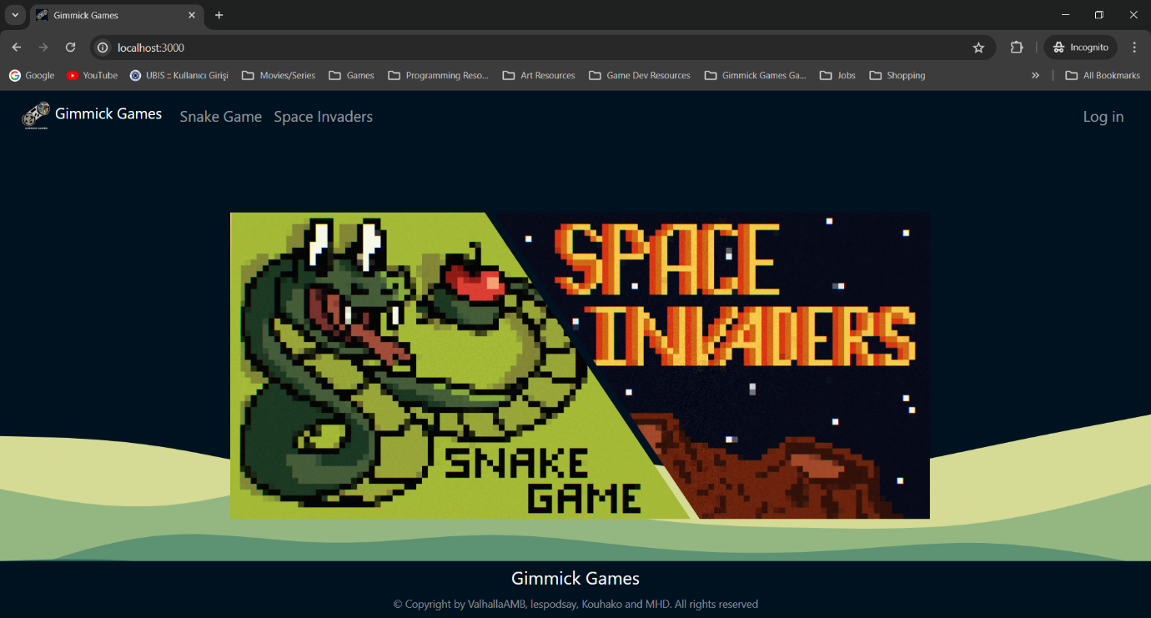Open a browser of your choice, and type in “localhost:3000” in the URL bar/location bar. Gimmick Games’s landing page should appear in your browser, like so:
* 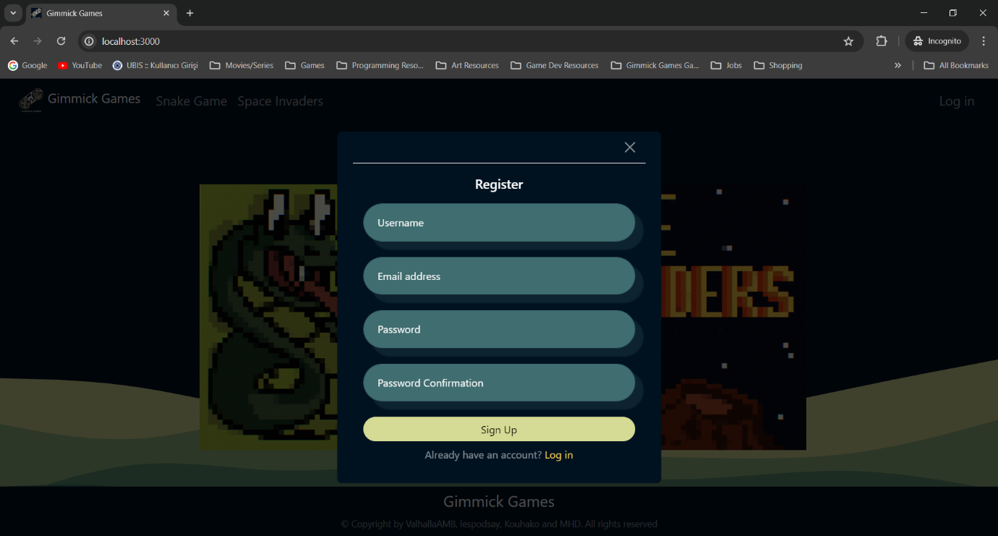From the landing page, the user can choose to sign up for a new account:
* log in if they have an existing account:

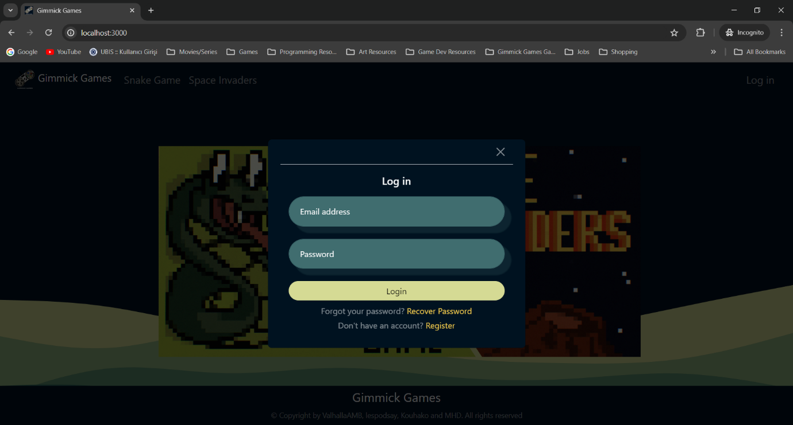

* view either game leaderboard (Snake Game) and save their scores if they’re logged in while playing the game:

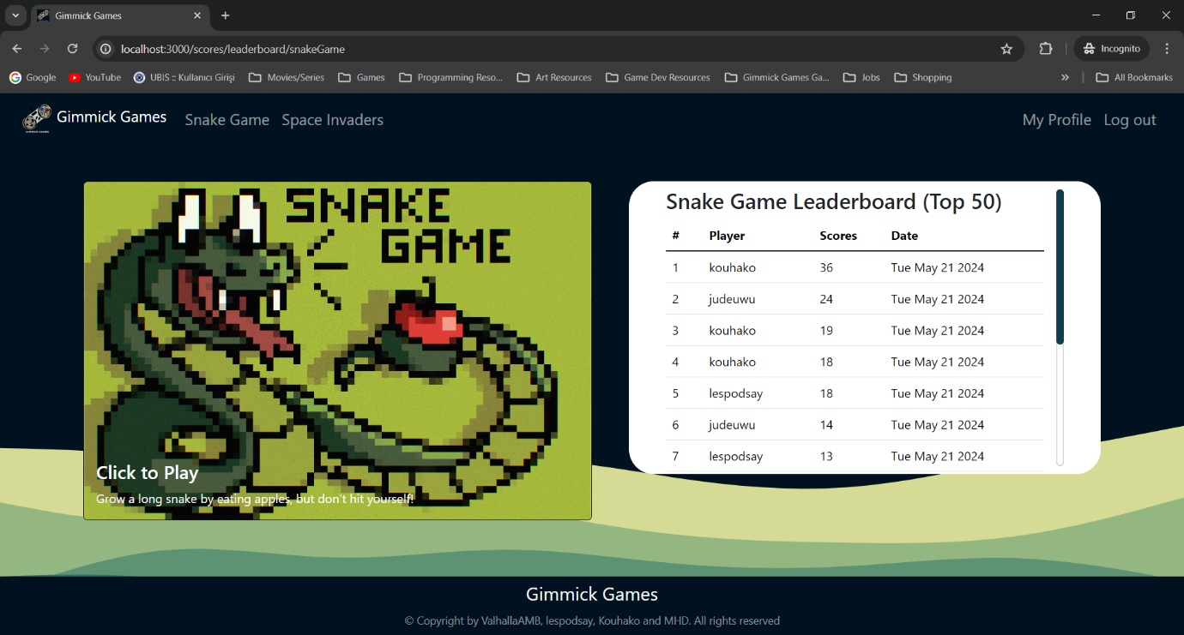

* 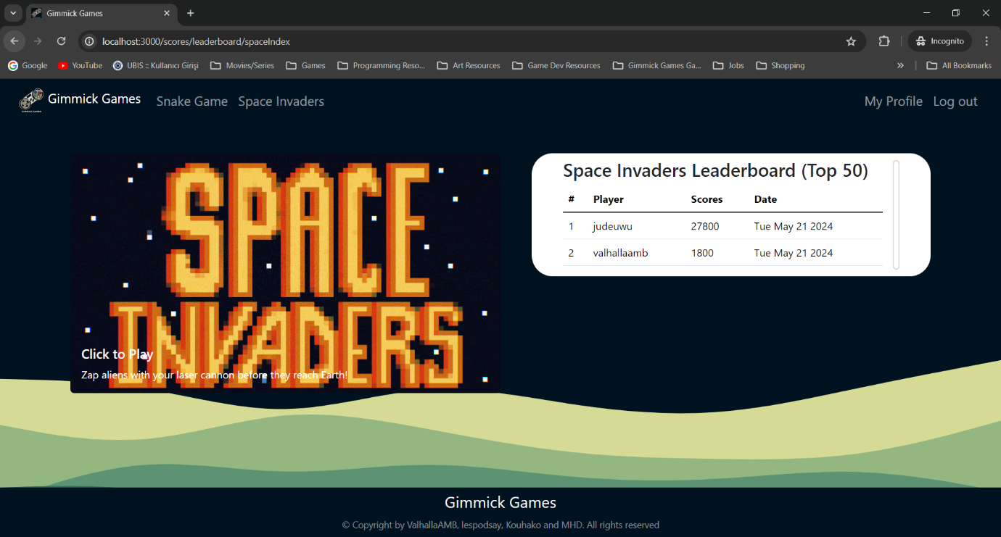view either game leaderboard (Space Invaders Game) and save their scores if they’re logged in while playing the games:
* play the games available on the website (Snake Game)

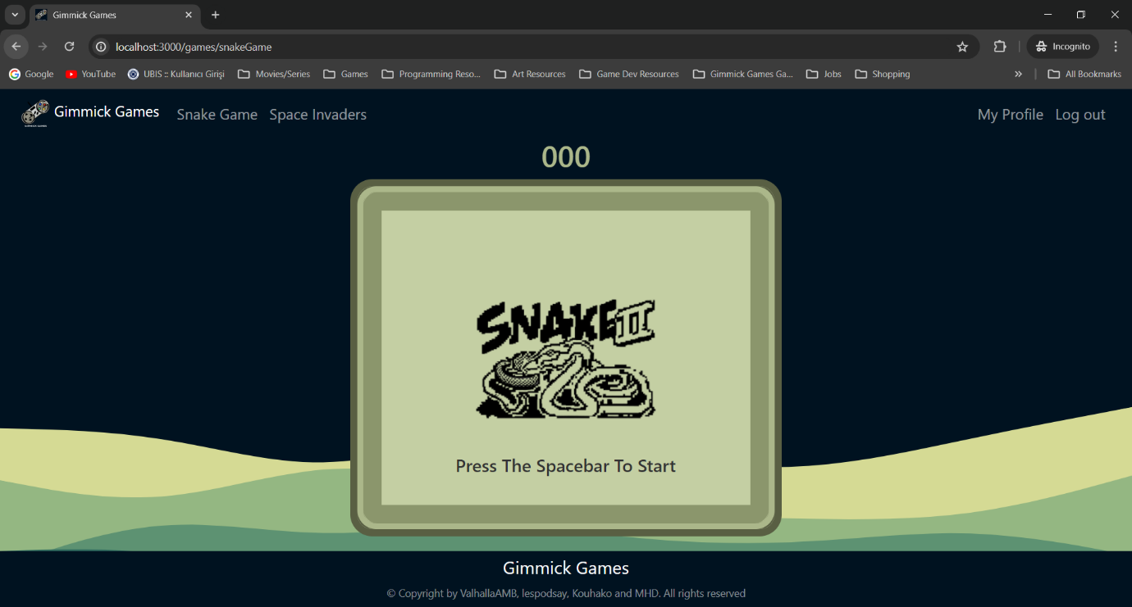

* play the games available on the website (Space Invaders Game)

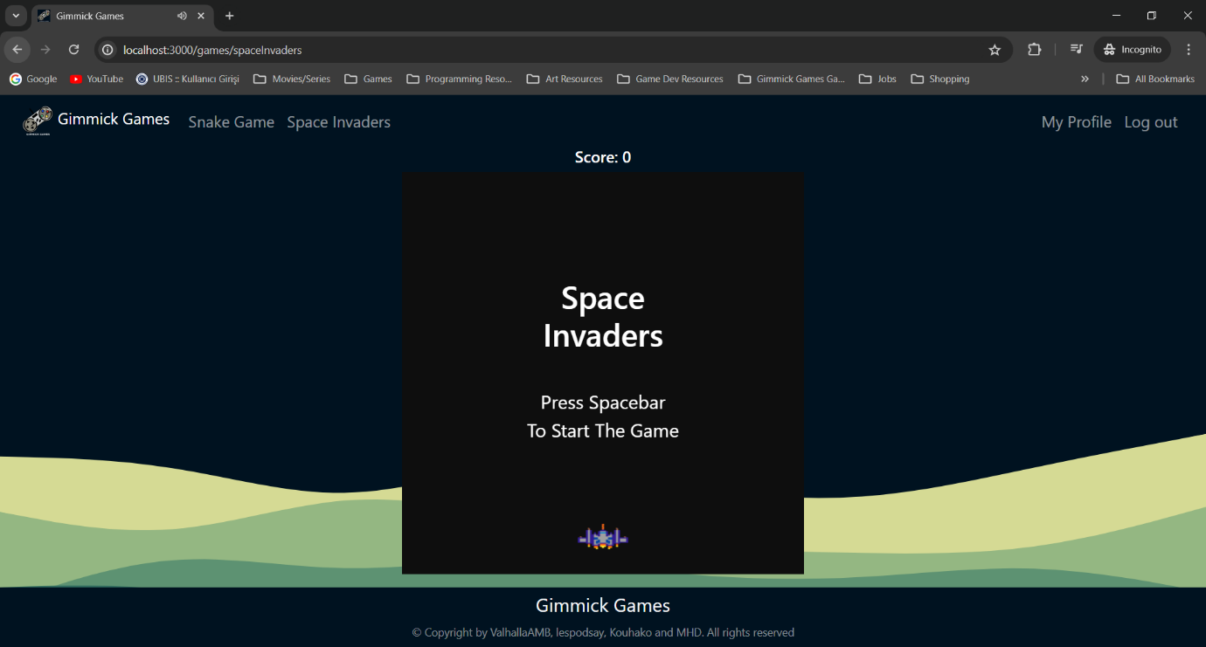

* Naturally, the scores are saved on the leaderboards of the respective game and in the user’s profile.

